EXPLORATORY DATA ANALYSIS PROJECT DOCUMENTATION

Introduction:
Exploratory Data Analysis (EDA) is the process of understanding and summarizing datasets through statistics and visualization.
This project focuses on extracting meaningful insights from raw data.

Project Goal:
To analyse the dataset and discovered:
-Data distributions
- Customer behaviour
- Trends
- Outliers

Methodology:
Step 1: Import Libraries
Used:
- Pandas
- NumPy
- Matplotlib

Step 2: Load Dataset
Dataset loaded into Data Frame using:
Python
pd.read_ excel()

Step 3: Explore Dataset
Performed:
-head()
-shape
-info()
-describe()

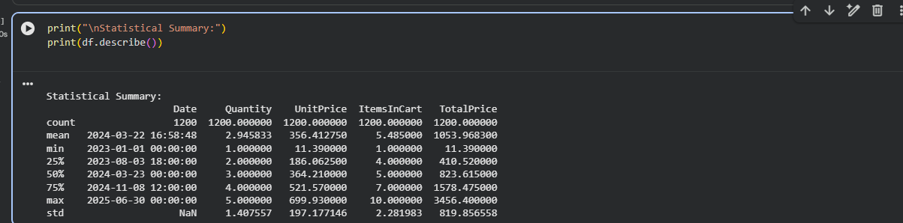

Step 4: Data Cleaning
Performed:
- Missing value analysis
- Duplicate detection

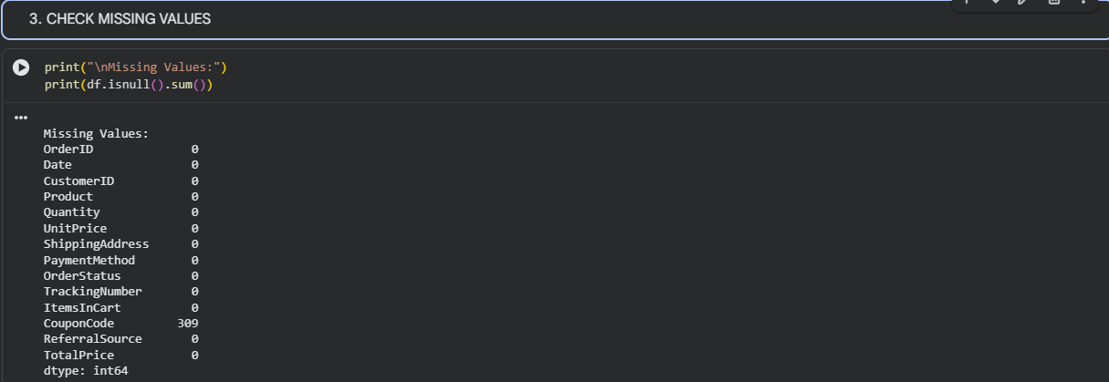

Step 5: Statistical Analysis
Calculated:
- Mean
- Median
- Counts

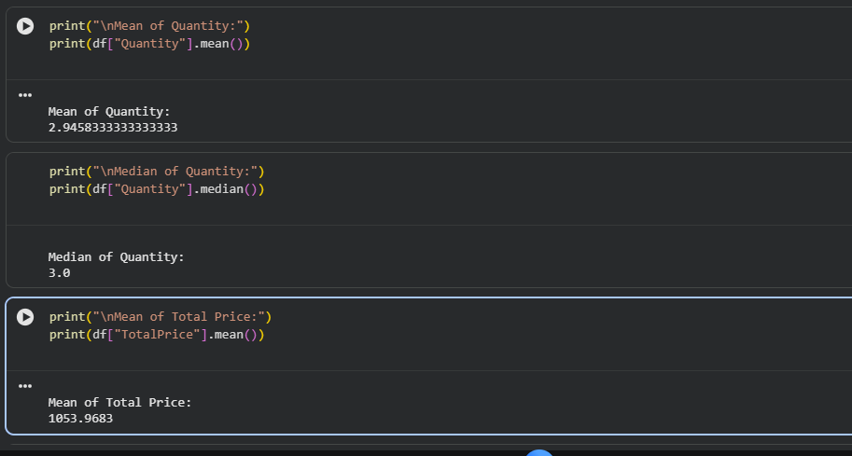

Step 6: Visualization
Created:
- Product Distribution
- Payment Method Pie Chart
- Referral Analysis
- Monthly Revenue Trend
- Histogram
- Box Plot

Results:
Findings
- Data quality evaluated
- Revenue trends identified
- Customer behaviour observed
- Outliers detected

Conclusion:
EDA provided insights into business performance and improved understanding of data-driven decision making.

Future Improvements:
- Dashboard creation
- Predictive analytics
- Machine learning integration

Author
Varalakshmi R

